NAME: SANGEETHA.N

ROLL NO. : 19UITE013

EX. NAME : Word Count Program Using MapReduce

DATE :15/10/2022

**Step 1:** Create a text file **“D:/data.txt”**

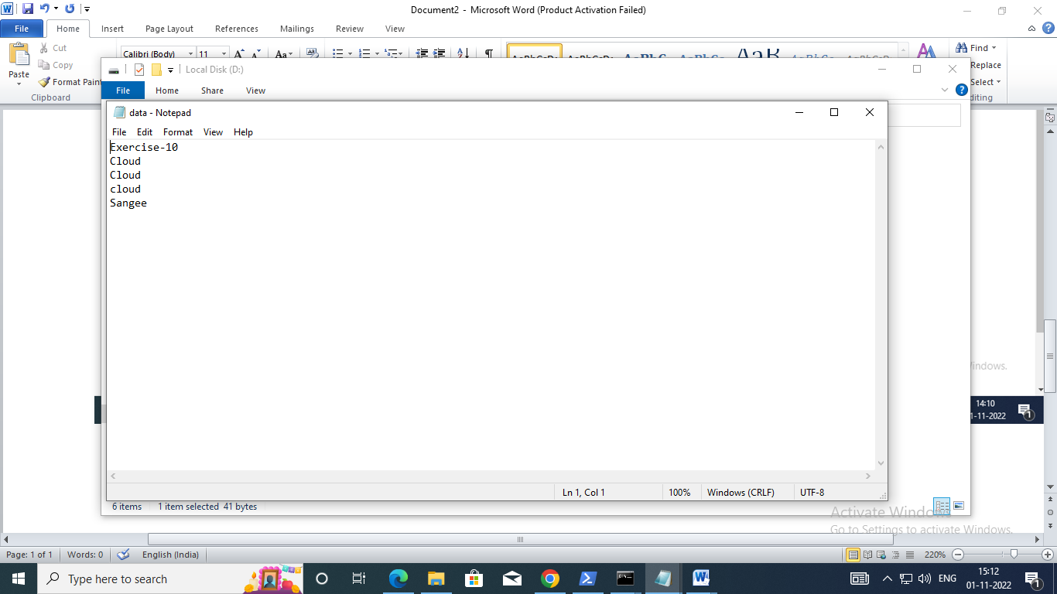

**Step 2:** Create a directory in HDFS, where to kept text file.

hdfs dfs -mkdir /user

**Step 3:** Upload the data.txt file on HDFS in the specific directory

hdfs dfs -put D:/data.txt /user

**Step 4:** List the files or directories in hdfs

hdfs dfs -ls /user/

**Step 5:** To view the content of the file **“/user/data.txt” hdfs dfs -cat /user/data.txt**

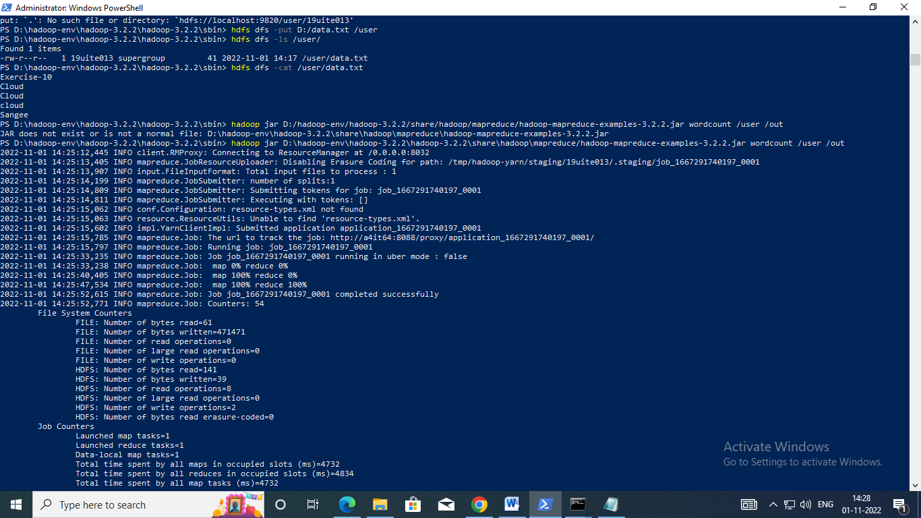

**Step 6:** Run the jar file

hadoop jar D:/hadoop-env/hadoop-3.2.2/share/hadoop/mapreduce/hadoop-mapreduce-examples- 3.2.2.jar wordcount /user /out



**Step 7:** To view the output in **“/out/*” hadoop fs -cat /out/\***

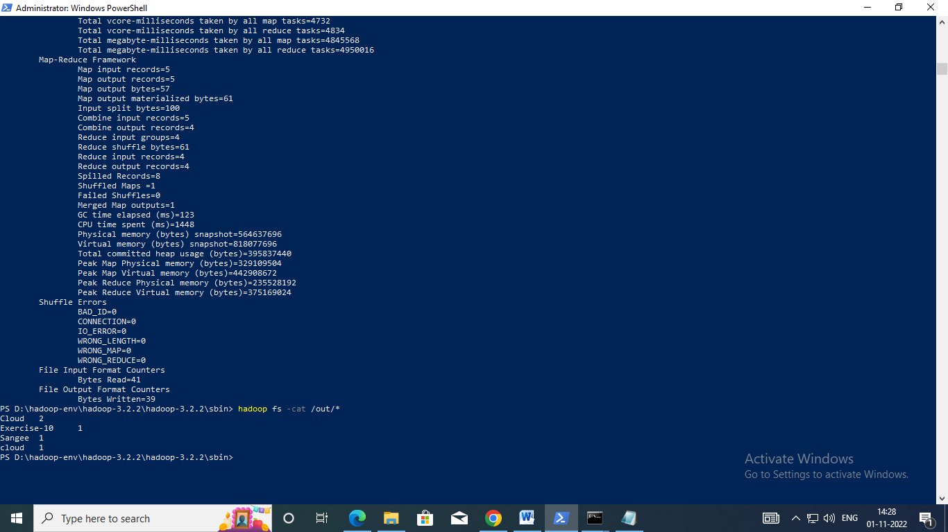

Output

